CNS-1000
(802) 461-5943
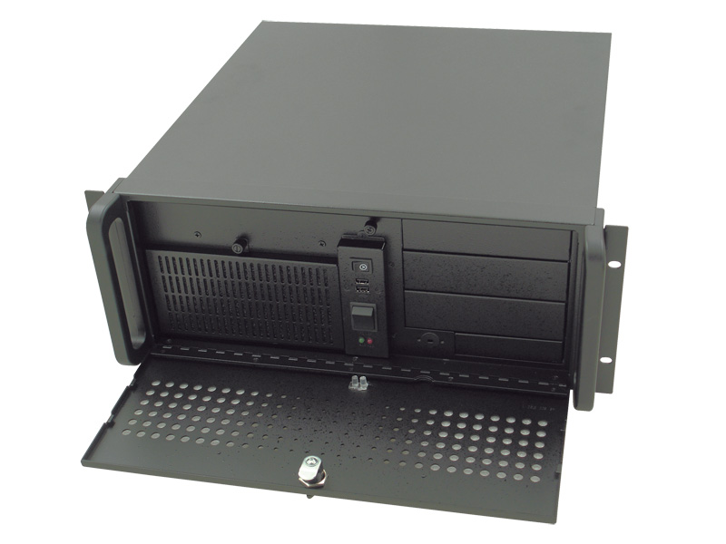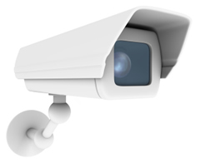
CNS-1000 is a fully expandable 4 to 16 channels video camera system that supports up to 30 fps (DVD Quality) display on each camera. Systems are designed and built to each customer’s needs.
Video & Audio live surveillance
• Simple and smart operation with mouse, remote or IE browser
• Up to 30 fps on each camera.
• Two-way audio transmission
• 1 / 4 / 6 / 7 / 8 / 9 / 10 / 13 / 16 split-screen display.
• System log and Operation log support
• Record / display / playback simultaneously
• Remote live monitoring and playback from any internet connection
• High video quality and low data rate
Recording & Playback
• Water mark to prevent fraud image modification
• Adjustable recording rates and resolution for each camera • Motion detection / Alarm trigger / Cyclic / Schedule / Weight recording
• Pre-motion or pre-alarm and post-motion or post-alarm recording
• Brightness and color adjustment during playback
• Digital Zoom-in during playback
• Thumbnail browsing support
• Bookmark function support
• Searching by time, day, motion, events or alarm log
Alarm function
• System audio alarm warns when alarm is triggered
• System automatically displays enlarged image when alarm is triggered
• Snapshot images through E-mail or FTP server when alarm is triggered
• Optional GPI/O for alarm control
Key Points

- Superior remote viewing over internet.
- Special compression software that allows more video to be stored on less drives space.
- Pre alarm (records video up to 10 seconds before incident.)
- You are able to record play back and view all at the same time
- Audio (Option) and video recording.
- No tapes all digital
- System will send you images if a camera detects motion on an off hour
- Connects to P.O.S register systems (Cash Register Option)
- Enhanced software makes it easy to search the system for event. (Thumb nail view, highlight area and have system search for all movement in selected area and 24 hour movement search)
- Indoor/Outdoor, Day/Night and PTZ (moveable) cameras
- Professional installation
- 24/7 customer support
- Free site consultation
- Built in DVD backup
- May reduce insurance premiums
- Take snapshots of live or recorded video
- Record video to remote location

(802) 461-5943

Comparison of CNS 1000 to others

- Most competitors systems are windows based. And as we all know windows machines get virus, slowdown, lockup and crash. You need a system that you can rely on.

- CNS 1000 operating system runs off of a chip with no moving parts. Other system runs on a hard drive with moving parts that tend to crash.

- CNS 1000 video is recorded on true DVR storage devices (design for continue recording function). Most competitors us computer hard drives.

- CNS 1000 is designed for each customer and his needs. Our competitors systems our off the shelf with little or no options for customization.

- CNS 1000 software upgrades are always free.

- A system that was purchased two years ago could be upgraded to work like a system we sell today.

- We do not charge any monthly service fee. We supply 30 day on site and 1 year return to factory warranty. We offer an on site maintenance contract or Time and material rates.

(802) 461-5943

